Mern stack social media application udemy prerak mehta

**Dependencies**

npm init -y

npm i --global yarn

yarn add express

yarn add mongoose dotenv helmet morgan nodemon

execution command : yarn start since using yarn

or nodemon index.js or npm run start if not yarn

mongodb online cloud db mongodb atlas username : keyaashah03

passcode : nfwN45x1wFdcQbvR

use free cluster change cluster name choose connect your application driver should be node.js and version latest copy 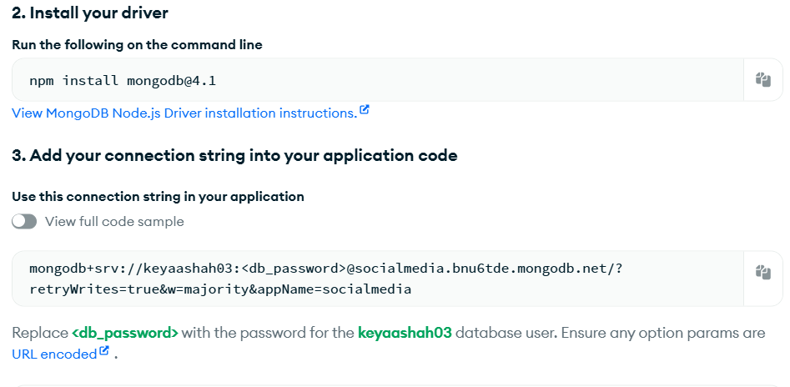

copy this things

npm install mongodb@4.1

mongodb+srv://keyaashah03:<db_password>@socialmedia.bnu6tde.mongodb.net/?retryWrites=true&w=majority&appName=socialmedia

PASTE mongodb+srv://keyaashah03:<db_password>@socialmedia.bnu6tde.mongodb.net/?retryWrites=true&w=majority&appName=socialmedia

THIS IN YOUR DOTENV FILE AND REPLACE <PASSWORD> WITH ACTUAL PASSWORD AND ADD DB NAME LIKE THESE

mongodb+srv://keyaashah03: nfwN45x1wFdcQbvR @socialmedia.bnu6tde.mongodb.net/socialmedia?retryWrites=true&w=majority&appName=socialmedia